
- Name: Sajjal Tariq
- Roll no: 10011
- Section: A (BSCS)
- Subject: Data Structure & Algorithm
- Submitted to: Sir Hassan
Lab no: 01

Basic Programming Concepts

Task: 01
Write a program that:
1. Takes integer n
2. If positive print even numbers till n
3. If negative, print odd numbers till -1
4. If zero print message.

Code:
#include <iostream>
using namespace std;
int main()
{
int n;
cout << "enter an integer ";
cin >> n;
if (n > 0)
{
cout << "Even numbers till " << n << ": ";
for (int i = 2; i <= n; i += 2)
{
cout << i << " ";
}
}
else if (n < 0)
{
cout << "Odd numbers till -1: ";
for (int i = n; i <= -1; i++)
{
if (i % 2 != 0)
cout << i << " ";
}
}
else
{
cout << "Number is zero. No even or odd numbers to display.";
}
return 0;
}
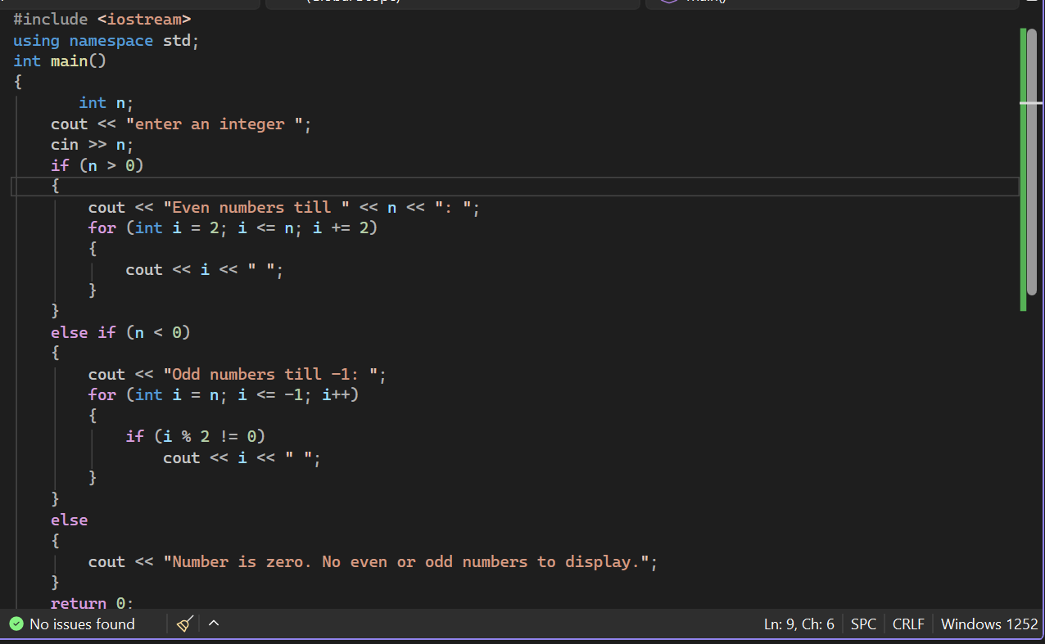
Output:
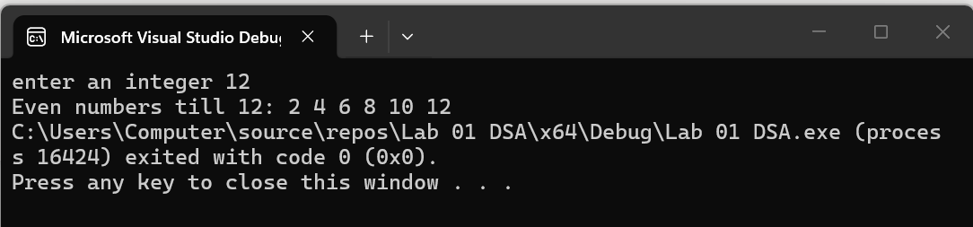
Task no 02:
Student Result Processing System: A university wants a simple result system for a class. Write a program that takes:
Total number of students, Marks (out of 100) For each student:
If marks ≥ 85 → Print "A Grade" If marks ≥ 70 and < 85 → Print "B Grade" If marks ≥ 50 and < 70 → Print "C Grade" Else → Print "Fail"
At the end, print: Number of passed students.Number of failed students
Constraints: Use loops for repeated input. Use an if-else ladder for grading. Use appropriate data types.
Code:
#include <iostream>
using namespace std;
int main()
{
int n, marks;
int pass = 0, fail = 0;
cout << "enter total students ";
cin >> n;
for (int i = 1; i <= n; i++)
{
cout << "Enter marks of student " << i << ": ";
cin >> marks;
if (marks >= 85)
{
cout << "A Grade" << endl;
pass++;
}
else if (marks >= 70)
{
cout << "B Grade" << endl;
pass++;
}
else if (marks >= 50)
{
cout << "C Grade" << endl;
pass++;
}
else
{
cout << "Fail" << endl;
fail++;
}
}
cout << "Passed students " << pass << endl;
cout << "Failed students " << fail << endl;

return 0;
}
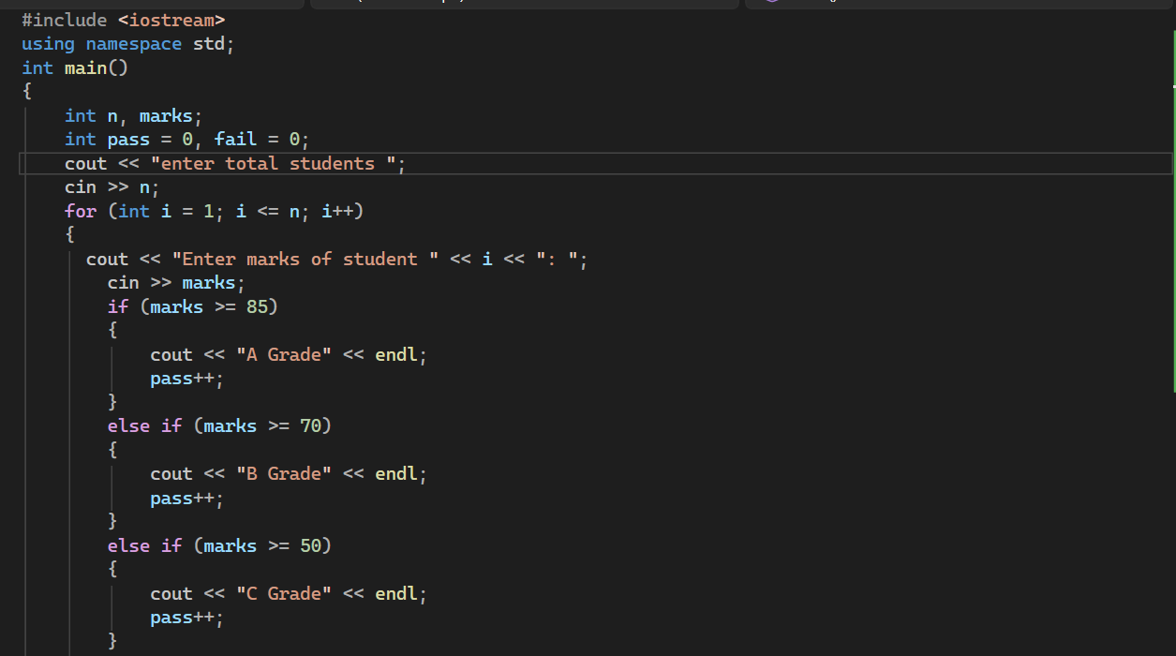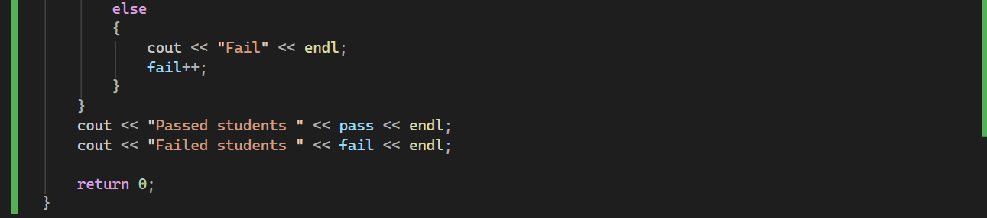
Output:
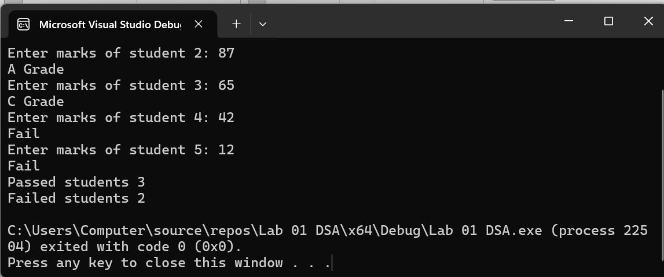
Task no 03:
Write a function my_power which takes two parameters, i.e. base & exponent, and returns result after calculations (result = base ^{exponent}). (Note: you cannot use built-in functions.)A prototype of the function must be
double my_power(double base, double exp);
Code:
#include <iostream>
using namespace std;
double my_power(double base, double exp) {
if (exp == 0)
return 1;
double result = 1;
int e = (int)exp;
if (e > 0) {
for (int i = 0; i < e; i++) {
result *= base;
}
}
else {
for (int i = 0; i < -e; i++) {
result *= base;
}
result = 1.0 / result;
}
return result;
}
int main() {
cout << my_power(90, 3) << endl;
cout << my_power(9, 4) << endl;
cout << my_power(7, -2) << endl;
return 0;
}
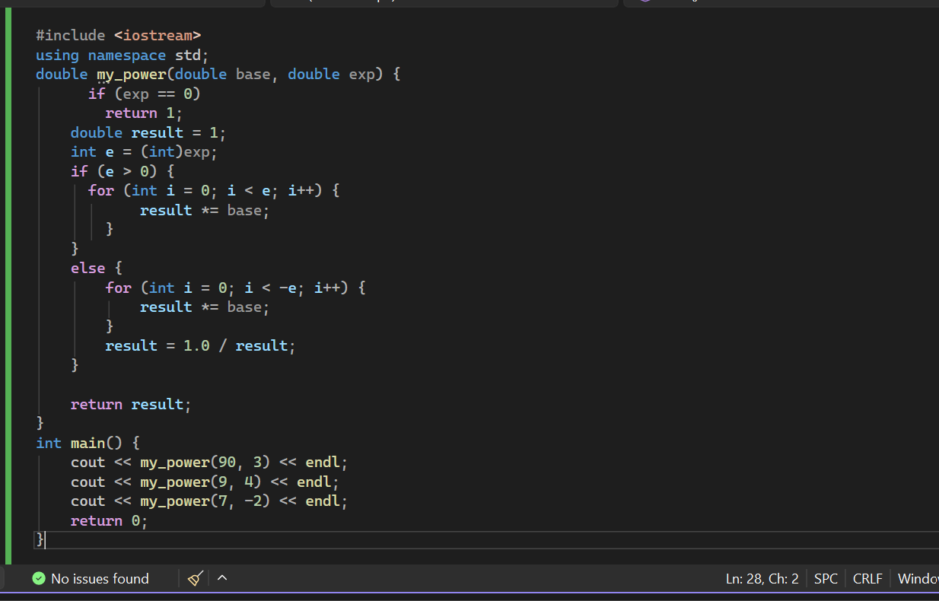
Output:
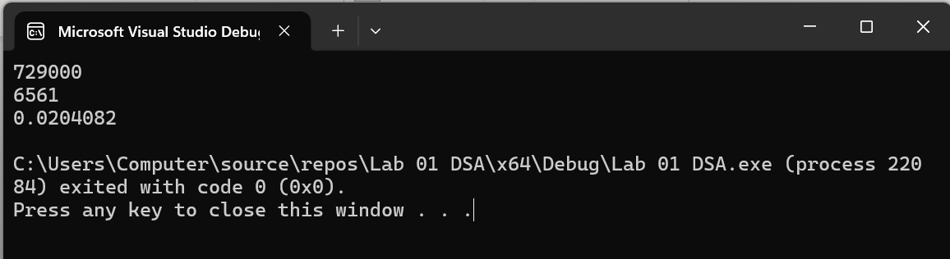
Task no 04:
You have an array of integers representing scores of students. Your task:
- Find the minimum and maximum elements in the array
- Swap these two values using a swap function that uses pass by reference only
Display should be: Array before swapping, Array after swapping
Code:
#include <iostream>
using namespace std;
void swapvalues(int& x, int& y) {
int temp = x;
x = y;
y = temp;
}
int main() {
int scores[] = { 90, 56, 43, 39, 42, 97 };
int size = sizeof(scores) / sizeof(scores[0]);
cout << "original array ";
for (int i = 0; i < size; i++) {
cout << scores[i] << " ";
}
cout << endl;
int smallest = 0, largest = 0;
for (int i = 1; i < size; i++) {
if (scores[i] < scores[smallest]) smallest = i;
if (scores[i] > scores[largest]) largest = i;
}
swapvalues(scores[smallest], scores[largest]);
cout << "Array after swaping min and max ";
for (int i = 0; i < size; i++) {
cout << scores[i] << " ";
}
cout << endl;
return 0;
}
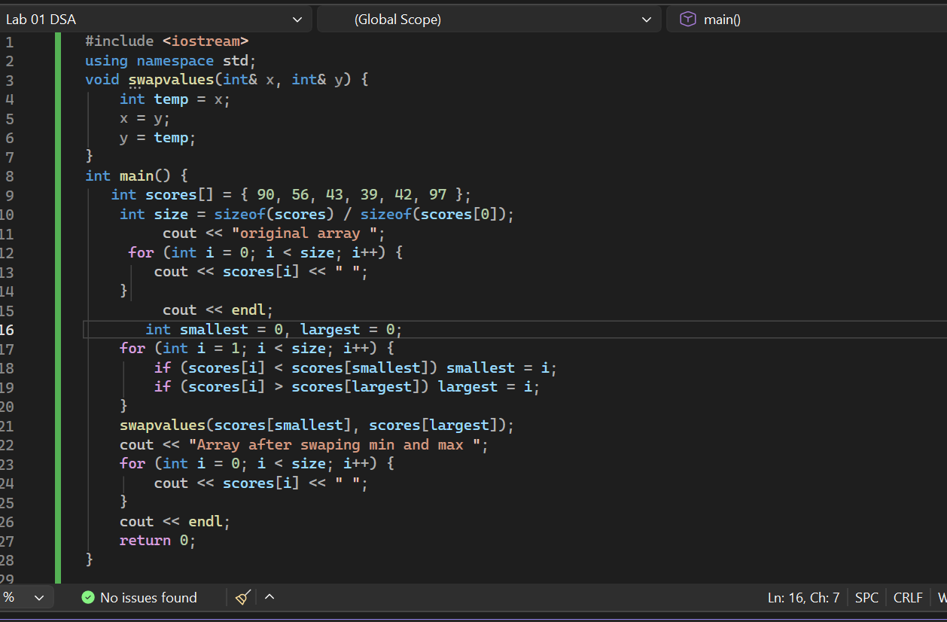
Output:
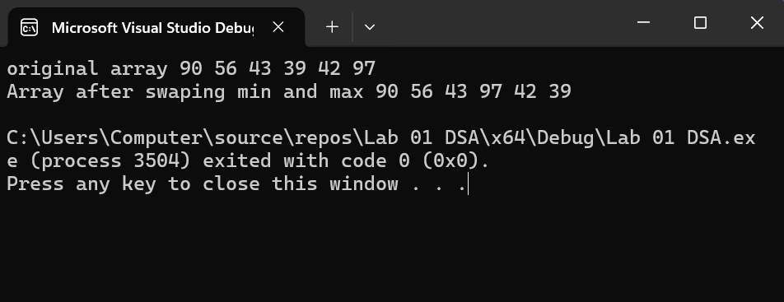
Task no 05
Copy the following program, compile it, and observe the output.
Code:
#include <iostream>
using namespace std;
int main()
{
int x = 25, y = 50, z = 75; // Three int variables
int* ptr; // Pointer variable

// Display the contents of x, y, and z.
cout << "Here are the values of x, y, and z:\n";
cout << x << " " << y << " " << z << endl;

// Use the pointer to manipulate x, y, and z.

ptr = &x; // Store the address of x in ptr
*ptr *= 2; // Multiply value in x by 2

ptr = &y; // Store the address of y in ptr
*ptr *= 2; // Multiply value in y by 2

ptr = &z; // Store the address of z in ptr
*ptr *= 2; // Multiply value in z by 2

//Display the contents of x, y, and z.
cout << "Once again, here are the values "
<< "of x, y, and z:\n";
cout << x << " " << y << " " << z << endl;
return 0;
}
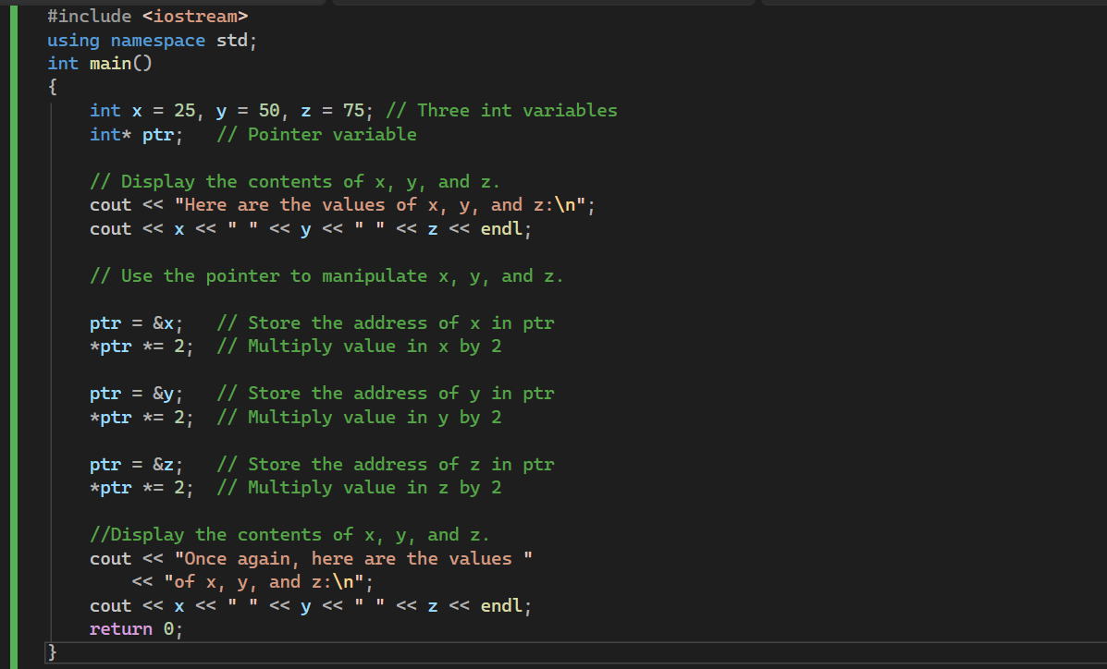Output: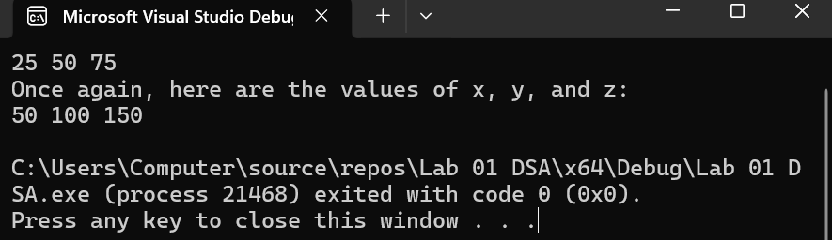
Task no 06:
Write a function:
void updateValue(int &x);
This function should: If x is even → multiply it by 3. If x is odd → add 7
Keep in mind: Take a number from the user. Call the function. Display the updated value.
Code:
#include <iostream>
using namespace std;

void updateValue(int& x) {
if (x % 2 == 0) {
x = x * 3;
}
else {
x = x + 7;
}
}
int main() {
int num;
cout << "Enter a number ";
cin >> num;

updateValue(num);

cout << "Updated value" << num << endl;
return 0;
}
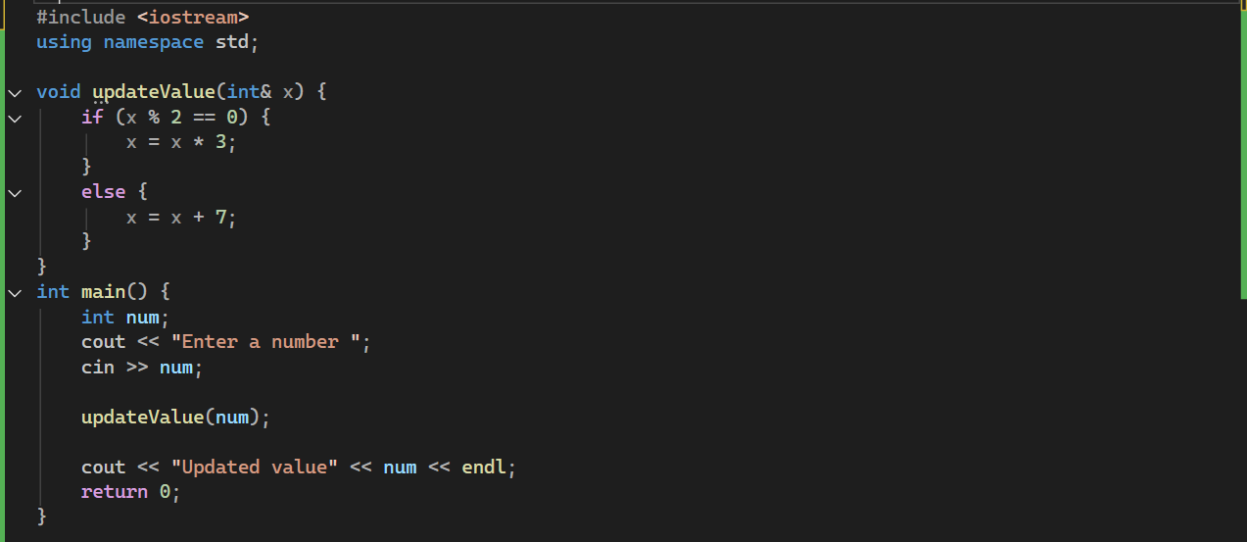

Output:
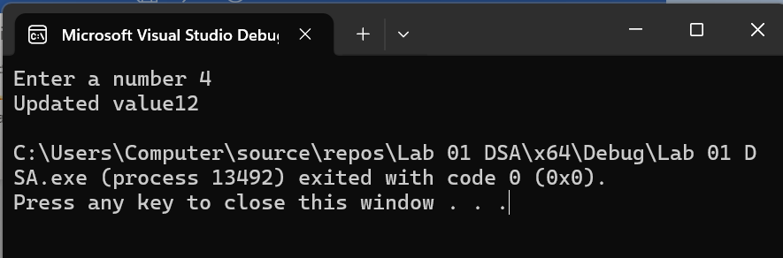
Task no 07:
A teacher wants to store the marks of 5 students dynamically.
Write a C++ program to:
- Dynamically allocate memory to store marks of 5 students.
- Take marks as input from the user.
- Print the marks.
- Free the allocated memory.
Code:
#include <iostream>
using namespace std;

int main() {
int* marks;
int n = 5;
marks = new int[n];

cout << "enter marks of " << n << " students " << endl;
for (int i = 0; i < n; i++) {
cout << "Student " << i + 1 << " ";
cin >> marks[i];
}
cout << "Marks of students are: ";
for (int i = 0; i < n; i++) {
cout << marks[i] << " ";
}
cout << endl;
delete[] marks;

return 0;
}

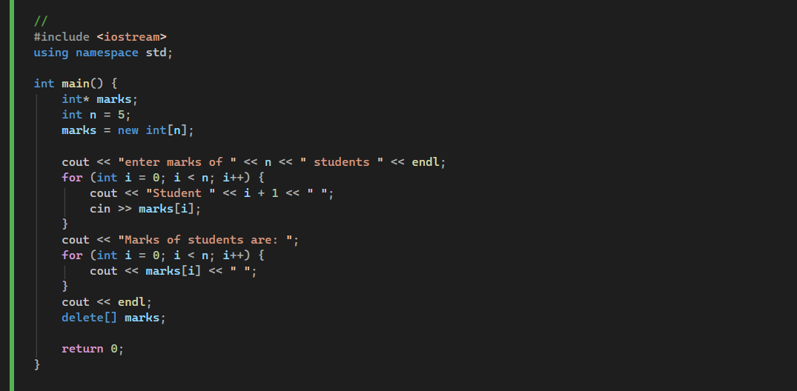
Output:
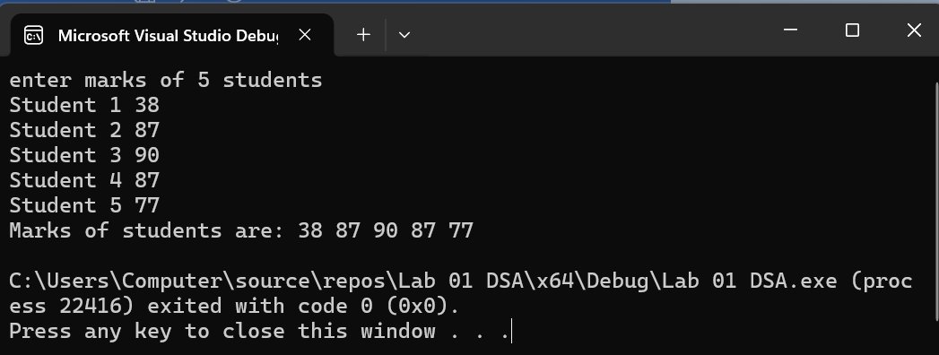
Task no 08:
Write a program to calculate the area using function overloading:
Area of a rectangle (length × breadth) , Area of a circle (π × radius²) , Area of a square (side × side)
Code:
#include <iostream>
using namespace std;

double area(double l, double b) {
return l * b;
}

double area(double r) {
double PI = 3.14159;
return PI * r * r;
}

int area(int s) {
return s * s;
}

int main() {
cout << "Rectangle area " << area(6.8, 1.9) << endl;
cout << "Circle area " << area(5.2) << endl;
cout << "Square area " << area(9) << endl;
return 0;
}
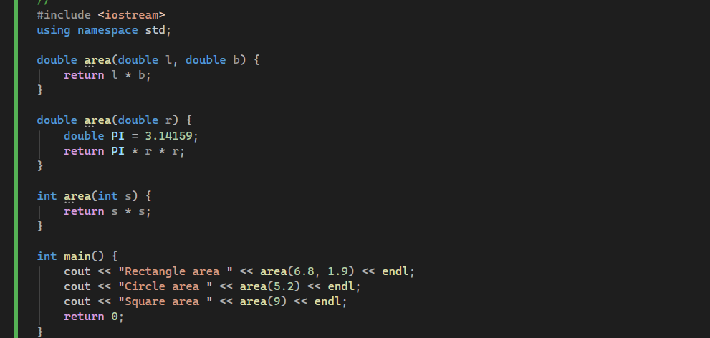
Output;
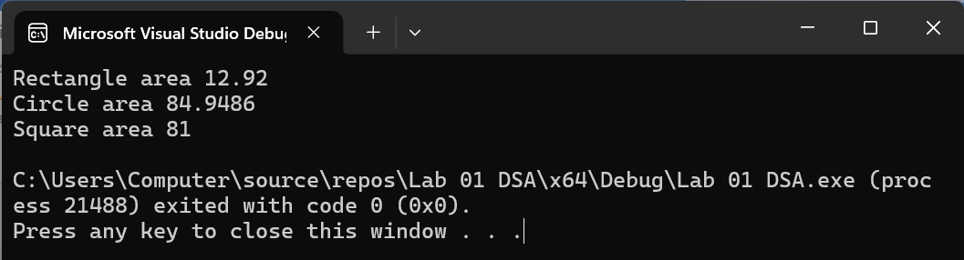

Task 9: Template 5 Marks

Write a function template sum to add two numbers of any type and return the result.
Code:
#include <iostream>
using namespace std;

template <class T>
T sum(T a, T b)
{
return a + b;
}

int main()
{
int x = 14, y = 20;
float a = 7.5, b = 3.5;

cout << "Sum of integers " << sum(x, y) << endl;
cout << "Sum of floats " << sum(a, b) << endl;

return 0;
}
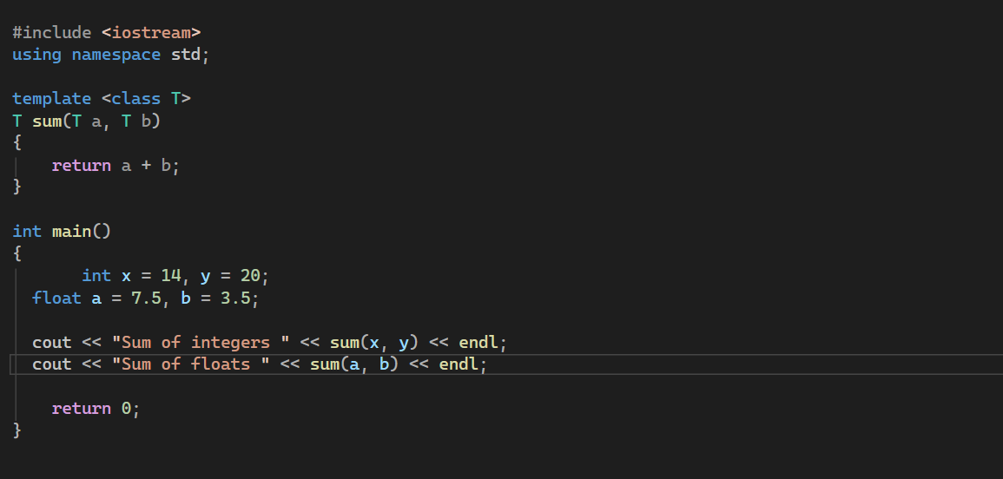
Output: 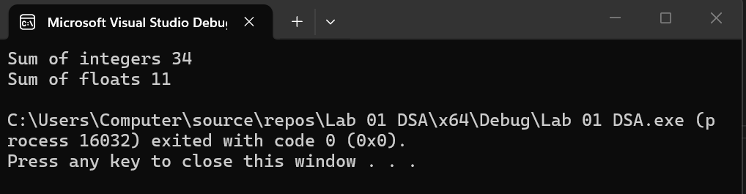

Task 2: Date Time 5 Marks

Write a function template to display a Date or Time in a formatted way.

Use a template so the same function works for both Date (day, month, year) and Time (hours, minutes, seconds).
Take input from the user and print the formatted result.
Example:
Input | Output
Date: 21 1 2026 | 21/01/2026
Time: 14 30 45 | 14:30:45

Code:
#include <iostream>
using namespace std;

template <typename T>
void display(T x, T y, T z, char sep) {
if (x < 10) cout << "0";
cout << x << sep;
if (y < 10) cout << "0";
cout << y << sep;
if (z < 10) cout << "0";
cout << z << endl;
}

int main() {
int dd, mm, yyyy;
cout << "enter date ";
cin >> dd >> mm >> yyyy;
cout << "Formatted Date: ";
display(dd, mm, yyyy, '/');

int hr, min, sec;
cout << "enter time ";
cin >> hr >> min >> sec;
cout << "Formatted Tim ";
display(hr, min, sec, ' ');

return 0;
}
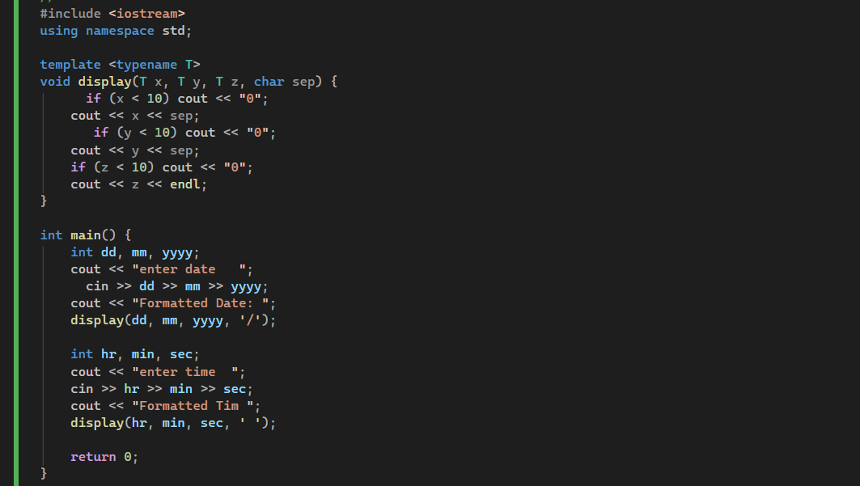
Output:
